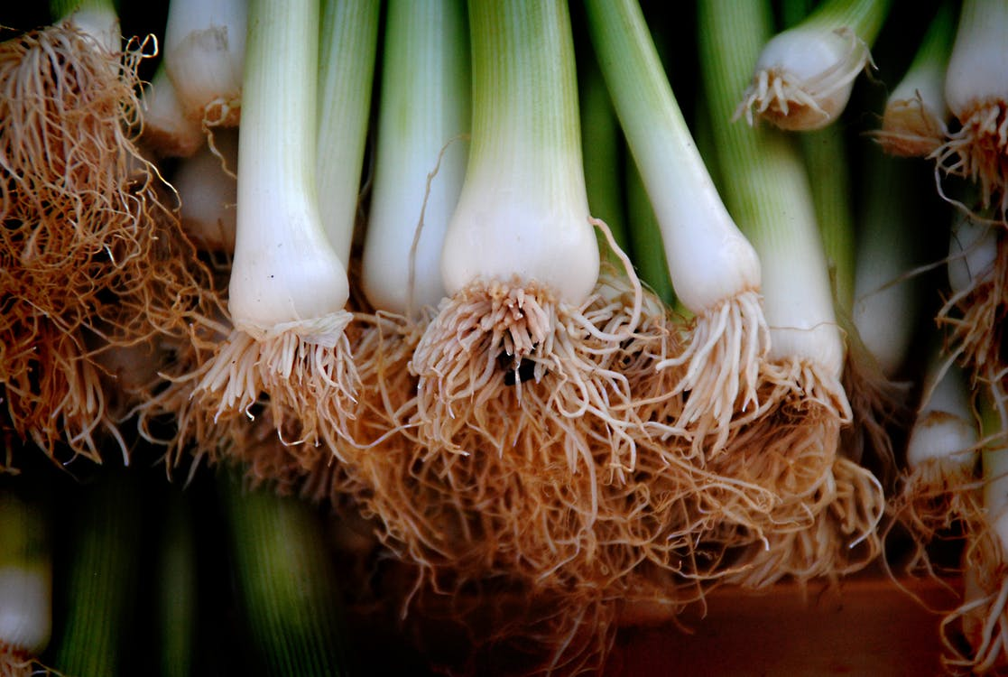

Leeks: Low in Calories and Fat, High in Nutritional Value and Flavor
I adore leeks. I fell in love with them when I was living in London (redundant I know, but true). Leek and potato soup/vichyssoise and leek vinaigrette were my absolute favorites. But, it wasn’t love at first site. I have to say that when I first learned of the health benefits leeks provide and how low in calories and salt they are while offering a lot of flavor, I wanted to start adding them to all my meals. However, just looking at them intimidated me. How do I eat them, how do I clean them? Do you eat the whole thing? I did some research and went to work in the kitchen and let me tell you something….don’t freak, it’s just a leek. Ha! It’s not nearly as daunting as I thought!
Because leeks are in season now, totally cheap and easy to get your hands on, I thought today I’d share a little Leeks 101 with you. Leeks come from the same family as onions and garlic and offer a lot of the same health benefits. In fact, they contain loads of nutrients (more on that in a minute) yet are very low in calories. 3 ½ ounces of leeks only has 31 calories therefore providing tons of flavor with little consequence.
Leeks can be eaten raw but also can be poached, fried, roasted, braised, pickled….you name it. I find them to be an incredible addition to soups, dips, stews, taco fillings, salads, quiches, stir-fries and potato dishes. Jonathan and I even love them on their own but our favorite way to eat leeks is in my potato leek soup (keep reading for the recipe later in this post)!
To prepare leeks, cut the roots and the dark green ends off and discard. You only want to eat the white and the light green portion of the leek. Then, slice them lengthwise and put them in a strainer in the sink under running water. Scrub away the dirt and sand that may be built up inside by really separating the layers. It seems like a big deal when you have a big portion of leeks to clean but I promise you it only takes a few minutes.
Leeks are milder in flavor compared to other varieties of onions but are a bit sweeter. They are essentially fat and cholesterol free and are low in salt (you know how important that it is to me)! Albeit small, they pack a mighty nutritious punch! Leeks are excellent for you because…
- Leeks contain significant amounts of the flavonoid kaempferol which studies suggest reduces the risk of developing chronic diseases—cancer in particular. It also appears to support our cardiovascular system by protecting our blood vessel linings and has shown to help lower your cholesterol and blood pressure.
- Leeks are a great source of vitamin A, which aids in vision and supports the immune system.
- Leeks are high in vitamin K which is crucial for your heart and bones. A 100 gram serving provides about 52% of the daily recommended value.
- Leeks are a good source of manganese which can help reduce premenstrual syndrome (PMS) symptoms and promote thyroid health.
- Leeks are high in prebiotic inulin fiber (up to 16%) which promotes healthy gut bacteria which helps the body breakdown fat! Prebiotics are so important because not only are they great for digestion, they help the microorganisms in our intestines grow which helps maximize the benefits of probiotics.

Leeks provide all of the above health benefits while also containing the sulfur containing compound allicin which is not only anti-bacterial, anti-fungal, and anti-viral, but research has also revealed that as allicin digests in your body, it produces sulfenic acid, a compound that neutralizes dangerous free radicals faster than any other compound ever!
In addition to all of the above, leeks are tasty, versatile, inexpensive and easy to prepare. One note to include before I share my infamous Potato Leek recipe with you….As you read the ingredients in my soup, I beg you not to look twice with fear at the two small potatoes that I include in a BIG batch of soup. Remember, carbs are not the enemy, moderation is key, and a diet rich in whole foods and food groups is the key to success.
I encourage you to expand your diet, to look away from the medicine chest and into the perimeter of the super market and to eat wholesomely. Stay in touch and stay well! Xx Janine

Janine’s Healthy Potato Leek Soup
Insert here

