Being Vocal About the Silent Killer

Happy, healthy (insert day of the week here), friends. I’m about to take you waaaaay back. We’re not close enough yet for me to tell you just how many years back (i.e. how old I am!), but we’re talking back to my childhood back!

I briefly mentioned in my post last week that my reasons behind pursuing a career in nutrition were deeply personal. Here’s why….
My health battle began when I was only 12 years old. Picture this…a very active, healthy looking, young girl goes to a routine summer camp physical and receives a shockingly high blood pressure reading. I didn’t feel sick, I didn’t look sick, but I was sick, very sick. I learned later on, the whole reason behind high blood pressure being coined the “Silent Killer”.

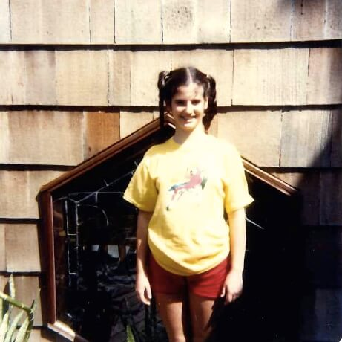
In my garden in Long Island at 12 years old

That summer, I was diagnosed with Renal Artery Stenois and my life was forever changed. I eventually ended up in the ICU and I swapped Summer camp for a hospital ward. I immediately underwent two trial procedures to see if my arteries could be opened up without major, invasive, surgery. Both failed. My whole family was in disbelief. Just weeks ago I had been healthy, or so we thought. But I was sick and this was serious. An extensive surgery that left a seven inch scar on my twelve year old body saved my life. My recovery was long and hard—school was missed and I was unable to participate in gym and sports. I began a round of blood pressure medication and that coupled with my need for being inactive lead to an almost 20 lb weight gain. I was at the lowest point of my life. I felt like an outcast even amongst my closest friends—I was sad and depressed.
Ok, ok… I’m not telling you all of this to get you to feel sorry for me. We all obviously know that this story has a happy ending. But, I promised you that I would share the “I wish I knew then what I know now” moments with you. I promised I would share the things that work for me, the things that helped me get healthy and stay healthy. So here I am. Sharing just what I promised. What I learned from this health scare is that even as an active twelve year old girl, my diet was literally killing me.

High Blood Pressure and Diet

Growing up, I never really felt like we were a family of “unhealthy eaters.” My parents always put a variety of foods in front of us (plenty of vegetables, meat and salads). I was by no means overweight and in general I felt very good. In retrospect though, what was harming me the most was salt—my childhood vice. I had no idea that the standard childhood diet of chips, hot dogs and pickles was literally killing me.

Identifying this trigger ended up saving my life. We all learned together as a family what our biggest diet pitfalls were. My parents did a complete overhaul of our whole diet and lifestyle. Here’s what we did:
- We stopped using salt completely and replaced it with different spices and herbs from around the world.
- We completely eliminated fast food, canned vegetables and canned soups.
- We drank only water and snacks became fresh fruits and vegetables.
- We all exercised more and through trial and error learned that stress was really bad for my blood pressure.
- I learned relaxation techniques for decreasing that stress and practiced biofeedback (more on that later).

Here’s what else I learned….I learned that salt makes your body hold onto water. Great! Extra hydration, right? WRONG! The more salt you ingest, the more stored water is in your system and extra stored water raises your blood pressure. The higher your blood pressure, the greater the strain on your organs which can lead to heart attacks, strokes, dementia and kidney disease. Not good!

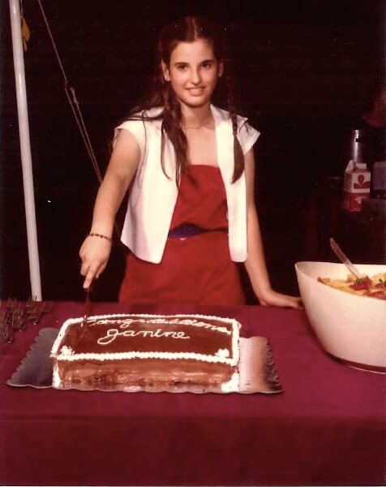
Happy to celebrate my 13th birthday at home with my family

Here’s what I wish, I wish I could provide you all with these red flags, things to look out for so that you would know exactly if you were experiencing high blood pressure. But you see, that’s the problem. That’s why this disease has been coined the “silent killer.”
Here’s what I can do. I can tell you to (obviously) stay on track with your yearly physicals and exams. And, I can share with you what has worked for me. Today, I exercise daily to keep my blood pressure low and to manage my stress. Instead of my fitness goals involving calorie blasting and waist trimming, I really try to focus on lowering my blood pressure and burning off stress. I’m very mindful in the kitchen. I cook without salt and I’m very particular when dining out about ordering. Annoying at times? Yes. Life Saver? Totally. I do take a daily blood pressure medication which is (literally) a hard pill to swallow for me. But, it’s a necessity and I’ve come to terms with that. In the next couple of months I’ll share my low salt/no salt tips from my kitchen with you. I’ll fill you in on how I can still eat out at restaurants and not have to stress out about. Just as I promised, I’ll share it all.
I’m hoping today that my personal story was in some way helpful to you. I want you to know that it’s not always the fat, the calories, the sugar that’s sabotaging your health and wellbeing. For me, salt was the “silent killer”. Take a good look at your diet and survey how much stress is in your life and whether or not you exercise enough. It seems simple but it’s so important. Today, I’ll leave you with a few more clinical tips on lowering blood pressure. Any specific questions? Shoot them my way. You know where to find me. This is just the beginning, I’ve got lots to share with your on this quest to living our most healthful, happy, life.
My Tips to Lower Blood Pressure:
- Stop cooking with salt – replace with herbs and spices
- Consume many more fruits and vegetables
- Less take-out. More at home-cooking
- Try incorporating more potassium rich foods like romaine lettuce, kale, swiss chard, beets, arugula and bananas into your diet.
- Eat beets. They are high in Nitric Oxide which opens vessels and reduces blood pressure
- Eat Fatty fish – salmon, tuna, herring, sardines, and mackerel. Omega 3’s will lower your blood pressure and reduce inflammation
- Exercise daily to reduce stress.

--JW
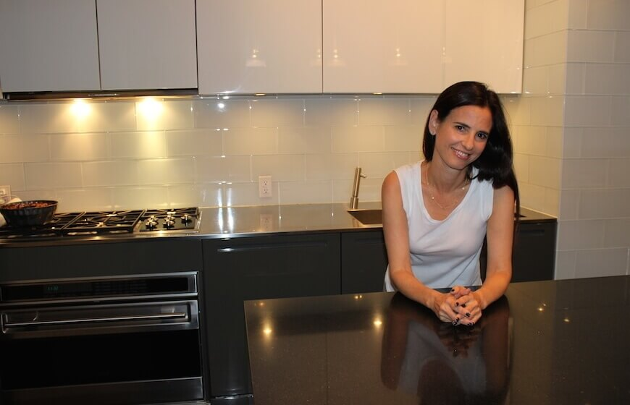
Stress-free in my favorite place at home

